**Gig Economy Application**

**Group 9**

Ramya Sree Vudugu

Pallavi Padam

Paavani Janapareddy

Introduction 4

1.1 Project Overview 4

1.2 Objectives 4

1. Effective Shift Management 4

2. Increased Flexibility 4

5. Scalability and Reliability 5

6. Data Security and Privacy 5

Methodology 6

2.1 Description of the Procedure 6

2.2 Justification 7

System Architecture 8

3.1 Front-end Design (Flutter) 8

User Interface (UI) Design 8

Navigation and Routing 8

3.2 Backend Technologies 8

Firebase Authentication 8

Firebase Firestore 9

3.3 Database Management 9

Data Modeling and Schema Design 9

Data Storage and Retrieval 9

Data Security and Compliance 9

Functionality 11

4.1 User Authentication System 11

Registration and Sign-Up 11

Login and Authentication 11

4.2 Job Posting and Application Process 11

Manager Job Posting 11

Employee Shift Application 11

4.3 Calendar Integration 12

Shift Calendar Sync 12

Calendar Notifications 12

4.4 Messaging System 12

Direct Messaging 12

Implementation Details 14

5.1 Technologies Used (Flutter, Firebase) 14

Flutter 14

Firebase 14

5.2 Development Process 15

Agile Methodology 15

Continuous Integration/Continuous Deployment (CI/CD) 15

Collaboration Tools 16

Market Analysis and Industry Impact 17

Market Analysis 17

• Shift Towards Flexible Work Arrangements 17

• Digital Transformation 17

• Focus on Employee Engagement 17

Industry Impact: 18

• Retailers 18

• Employees 18

Project Scope 19

User Authentication System 19

Shift Posting and Application Process 19

Calendar Integration 19

Messaging System 19

Technology Stack 19

Timeline 21

Week 1: Planning and Prototyping 21

Day 1-2: Project Kickoff and Requirements Gathering 21

Day 3-4: Technical Architecture Design 21

Day 5-6: Development Setup and Environment Configuration 21

Week 2: Implementation and Testing 22

Day 7-9: Front-end Development 22

Day 10-12: Back-end Development and Integration 22

Day 13-14: Testing, Deployment, and Finalization 22

Risk Analysis 23

Technical Risks 23

Dependency Compatibility 23

Security Vulnerabilities 23

Operational Risks 23

Deployment Failures 23

Scalability Challenges 23

Project Management Risks 24

Scope creep 24

Resource Constraints 24

Conclusion 25

References 26

# Introduction

## 1.1 Project Overview

The goal of the Retail "Gig" Mobile Application is to completely transform the way people look for and accept temporary jobs in the retail sector. This mobile app, which was inspired by the features of well-known platforms like Uber and DoorDash, offers a smooth way for job seekers and retailers to interact and effectively manage shift schedules.

Essentially, the application functions as a job board wherein nearby retailers can list open positions, and potential workers can search and apply for these positions according to their availability and skill set. The app increases productivity and flexibility for both employers and employees by streamlining the shift scheduling and management process by utilizing contemporary mobile technology.

A user-friendly interface for browsing and applying shifts, real-time communication between employers and employees, integrated calendar functionality for tracking shifts, and secure authentication to guarantee data security and privacy are some of the app's key features. In order to empower both workers and businesses in the retail industry, the Retail "Gig" Mobile Application provides a comprehensive solution to the problems associated with traditional shift scheduling.

## 1.2 Objectives

The Retail "Gig" Mobile Application's main goal is to solve the problems and inefficiencies that come with using conventional retail shift scheduling procedures. Through the use of contemporary software tools and mobile technology, the application seeks to accomplish the following main goals:

1. Effective Shift Management: Make it easier for employees and retailers to post, apply for, and oversee shifts.
2. Increased Flexibility: Give employees more freedom to choose their own work schedules, which will promote work-life balance and job satisfaction.

3. Better Communication: Ensure openness and clarity throughout the shift scheduling process by facilitating easy communication between employers and employees through built-in messaging options.

4. Streamlined Workflow: To reduce manual involvement and improve workflow, automate regular tasks like shift acceptance, calendar updates, and notifications.

1. Scalability and Reliability: Create a platform that is both scalable and dependable, able to support an expanding user base and manage peak loads during times of high demand.
2. Data Security and Privacy: Put strong security measures in place to protect user data and guarantee adherence to pertinent privacy laws, building user confidence and trust.

The Retail "Gig" Mobile Application aims to enhance productivity, adaptability, and communication during the retail shift scheduling process, which will ultimately help employers and employees in the retail sector.

# Methodology

## 2.1 Description of the Procedure

Following accepted software development practices, the retail "gig" mobile application was developed through a number of crucial phases. First, we thoroughly examined the needs of the users and the project requirements. The development phases that followed were led by this analysis, ensuring that they were in line with the anticipated features and goals of the application.

After the analysis, we moved on to the design phase, where the components of the user experience (UX) and user interface (UI) were developed and polished iteratively. We created the application's front end using the Flutter framework, emphasizing user-friendly navigation, eye-catching layouts, and smooth interactions. To guarantee the best possible usability and functionality, wireframing, prototyping, and ongoing feedback collection were all part of the design process.

After the UI/UX design was complete, the real coding and programming work moved into the implementation phase. We constructed the application's front-end components by utilizing the features of the Flutter framework, guaranteeing interoperability with a range of mobile devices and screen sizes. Concurrently, Firebase services were used to put up the back-end infrastructure, such as Firebase Cloud Messaging for real-time communication, Firestore for database administration, and Firebase Authentication for user authentication.

Agile methodology was used throughout the development process, enabling iterative development cycles and continuous integration of new features and improvements. To ensure consistent development and on-time delivery, regular sprints were held, with each sprint concentrating on a particular user story or feature. Strict testing protocols, such as unit, integration, and user acceptability testing, were used during the development stage to find and fix any problems or defects as soon as possible.

The application was put through a rigorous quality assurance process after the development phase was over to make sure it complied with security standards, performance benchmarks, and functional objectives. Remaining concerns were addressed and the user experience was further improved by incorporating feedback from user acceptance testing and beta testing.

## 2.2 Justification

The retail "gig" mobile application's development process was carefully chosen based on how well it fit the project's goals and needs.

Because of its flexible and iterative nature, which enables incremental development and adaptability to changing requirements, the agile methodology was selected. This made it possible for us to order features according to user input and business requirements, guaranteeing the timely delivery of an application that is both useful and user-focused.

Several benefits came from using the Flutter framework for front-end development: hot reload functionality for quicker development cycles, quick prototyping, and a single codebase that worked with both iOS and Android. This expedited development process preserved a consistent user experience across platforms while lowering development costs and time-to-market.

A scalable and dependable back-end infrastructure with features like real-time data synchronization, strong security measures, and easy authentication workflows was made possible by integration with Firebase services. As a result, we were able to concentrate on developing the core functionality of the application and the user interface rather than having to manage complicated server architecture.

Overall, the chosen technique made it possible for us to quickly and effectively design and produce a feature-rich and reliable mobile application that satisfies the requirements of store managers and staff, promoting easy shift scheduling, communication, and teamwork within the retail sector.

# System Architecture

## 3.1 Front-end Design (Flutter)

The retail "Gig" mobile application's front-end design was created utilizing the well-liked open-source UI toolkit Flutter framework by Google. Flutter is a great option for cross-platform development since it provides a full suite of tools and libraries for creating natively compiled desktop, web, and mobile applications from a single codebase.

### User Interface (UI) Design

The application's UI design put a lot of effort into making the user interface both aesthetically pleasing and intuitive. We created a variety of user interface (UI) elements, including buttons, text fields, lists, and navigation menus, using Flutter's extensive widget library to guarantee consistency and usability across various screens and device sizes. To satisfy particular design specifications and improve the application's overall visual attractiveness, customized widgets were created.

### Navigation and Routing

The application's user interfaces and screens may be seamlessly navigated between thanks to Flutter's integrated routing and navigation mechanism. We created a hierarchical navigation framework that makes use of drawer menus, stack-based navigation patterns, and bottom navigation tabs to let users move between the application's many components. Transitions between routes and navigation were streamlined for seamless operation and improved user experience.

## 3.2 Backend Technologies

Firebase, a feature-rich platform offered by Google for creating and distributing mobile and web applications, was used to construct the backend infrastructure of the Retail "Gig" Mobile Application. With its extensive backend development capabilities, including as real-time database, cloud storage, authentication, and cloud messaging, Firebase is an excellent choice for developing scalable, reliable apps with little to no server-side code.

### Firebase Authentication

The application's secure user authentication and authorization processes were implemented through the utilization of Firebase Authentication. Users could sign up, log in, and securely authenticate using Google Sign-In, email and password credentials, or other supported authentication providers by utilizing Firebase Authentication. To provide proper access rights and data protection, user role-based access control (RBAC) and custom authentication flows were put into place.

### Firebase Firestore

The main database used to store and manage application data, such as user profiles, shift listings, calendar events, and message transcripts, was Firebase Firestore. A NoSQL database that is scalable, adaptable, and real-time, Firestore allows for seamless data synchronization between client-side and server-side contexts. In order to effectively represent the application's data model, we organized the database schema. We then optimized queries and data retrieval processes for increased scalability and performance.

## 3.3 Database Management

### Data Modeling and Schema Design

The Retail "Gig" Mobile Application's database schema was created to support the different data entities and relationships necessary for the operation of the application. Using Firestore's collections and documents, we implemented a document-oriented data model to arrange and store data in a hierarchical structure. Every type of data entity—users, shifts, messages, and calendar events, for example—was represented as a distinct collection of documents with matching fields and properties.

### Data Storage and Retrieval

We were able to effectively access, filter, and sort data according to particular criteria and conditions because to Firestore's robust querying features. Based on user preferences and engagement patterns, we created query-based data retrieval algorithms to get pertinent information, including available shifts, user communications, and calendar events. Any modifications made to the database were instantly transmitted to linked clients thanks to Firestore's real-time data synchronization, enabling smooth data updates and notifications.

### Data Security and Compliance

During database maintenance, ensuring data security and compliance with privacy standards was of utmost importance. To prevent harmful activity and limit unauthorized access to critical data, Firebase has integrated security rules and access controls. In order to enforce role-based access controls, authentication requirements, and data validation, we put in place granular security rules. This made sure that only authorized users could access and edit pertinent data items.

The Retail "Gig" Mobile Application's system architecture consists of a scalable backend infrastructure based on Firebase technologies, a reliable front-end design done with Flutter, and effective database management techniques utilizing Firestore. We have created a feature-rich and intuitive application that caters to the requirements of retail managers and staff by utilizing these technologies and design concepts. This allows for smooth shift scheduling, communication, and teamwork within the retail sector.

# Functionality

## 4.1 User Authentication System

The Retail "Gig" Mobile Application's User Authentication System streamlines and secures the user registration, login, and authentication processes. Users may create accounts, sign in, and utilize the application's features with confidence knowing that their credentials are secure thanks to the use of Firebase Authentication services.

### Registration and Sign-Up

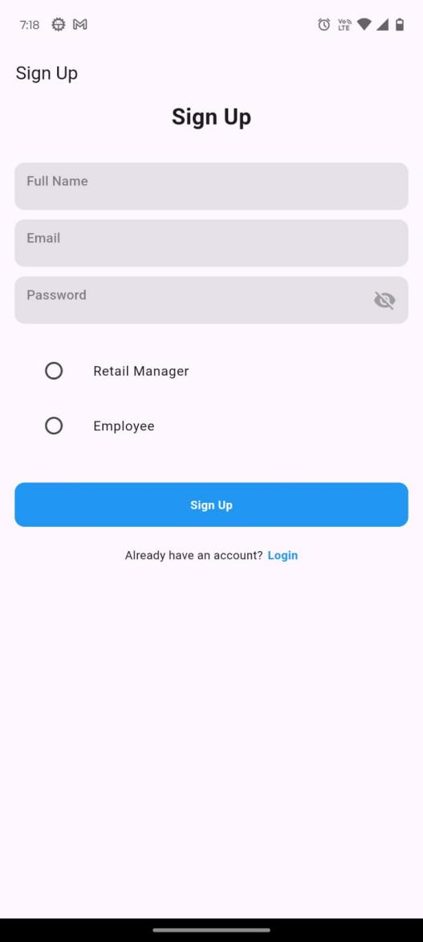

By entering basic details such a username, email address, and password throughout the registration process, new users can create accounts. User information is safely saved in the Firebase Authentication system after registration, guaranteeing data integrity and shielding it from unwanted access.

### Login and Authentication

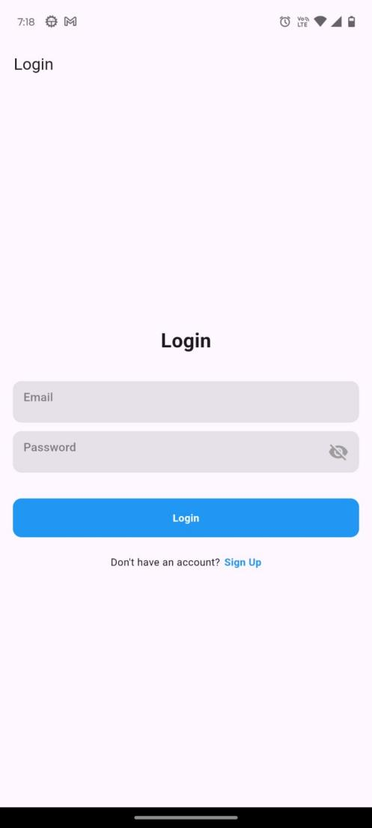

With choices for third-party authentication providers like Google Sign-In or email/password authentication, registered users can access the application by logging in with their credentials. The authentication process is managed by Firebase Authentication, which protects against unwanted access attempts and security threats while authenticating users and allowing access to approved users.

## 4.2 Job Posting and Application Process

Retail managers can publish employment shifts to a worldwide job board using the employment Posting and Application Process capability, which also lets staff members look for and apply to shifts that fit their schedules and preferences. This feature makes it easier for managers and staff to collaborate and communicate with one another, which makes workforce management and shift scheduling more effective.

### Manager Job Posting

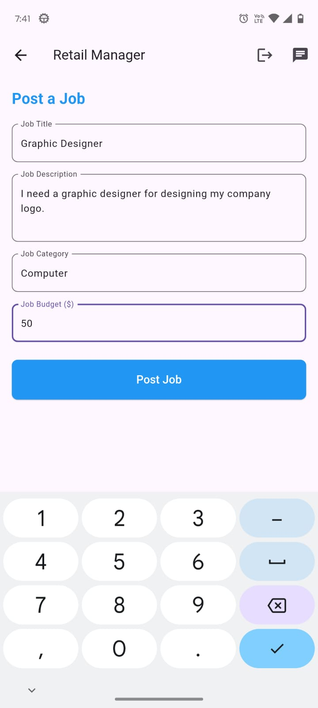

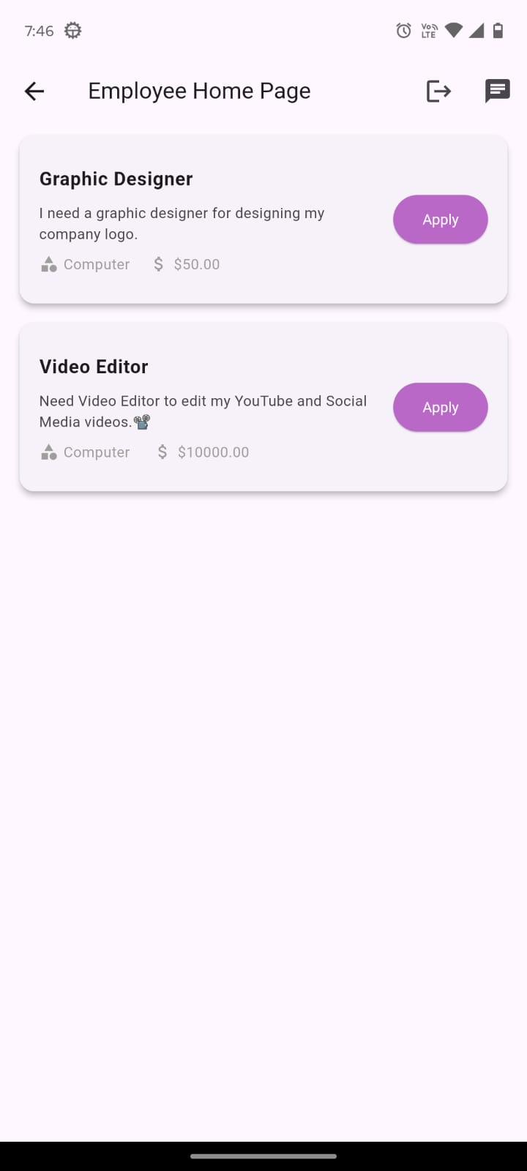

### Job Assigning

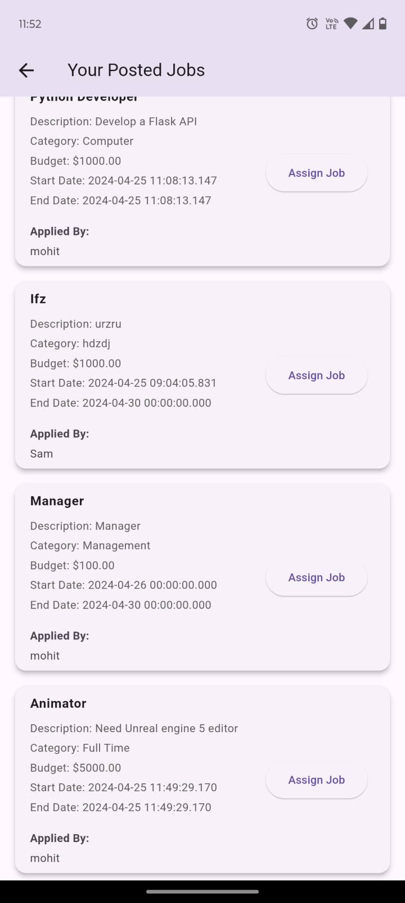

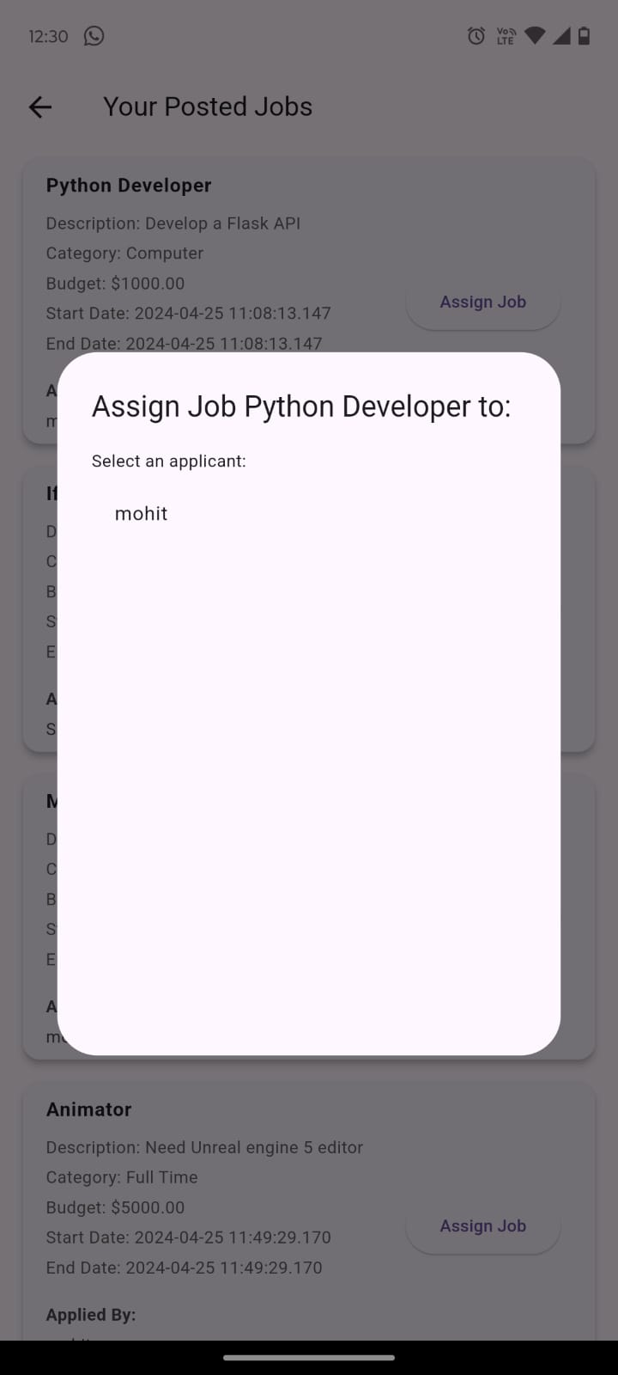

Retail managers can use the user-friendly interface of the application to generate and post job shifts to the global employment board. They can provide detailed information to entice possible applicants by specifying shift details like the date, time, location, job description, and necessary abilities. The posting procedure makes sure that job openings are appropriately shown to prospective candidates and efficiently meet staffing needs.

### Employee Shift Application

Workers can search the global employment board, see the shifts that retail managers have listed, and apply to the positions that fit their availability and skill set. Through the application procedure, workers can indicate their interest in taking on particular shifts by submitting their applications with the necessary information and credentials. Retail managers receive notifications when applications are submitted, allowing them to analyze and react to staff applications as needed.

## 4.3 Calendar Integration

Shift schedules and calendar events are automatically incorporated into users' calendars by the Calendar Integration feature, giving users visibility and organization over forthcoming shifts and appointments. Users may effectively manage their schedules and guarantee timely attendance and participation in scheduled shifts by syncing shift data with calendar software.

### Shift Calendar Sync

When a retail manager approves a shift application, the employee's and management's calendars are automatically updated with the given shift. By keeping everything in sync, all pertinent parties are aware of impending changes and are able to adjust their plans accordingly. Calendar events provide information on the shift, including the date, time, and place as well as any other notes the manager may have supplied.

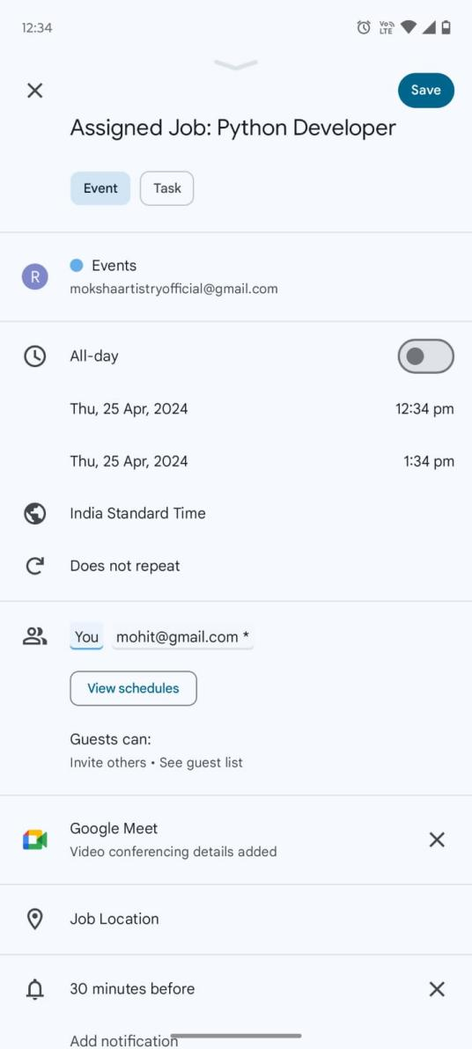

### Calendar Notifications

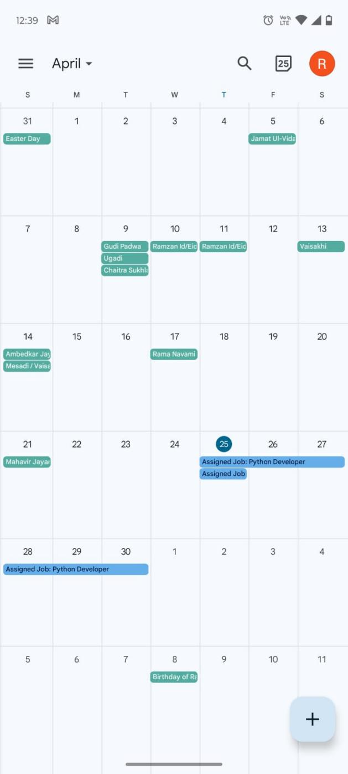

Notifications and reminders about impending shifts and activities are sent out via calendar integration, reducing the possibility of missed appointments and guaranteeing punctual attendance. Notifications about impending shifts are sent to users via email or their mobile devices, giving them easy access to shift specifics and location data.

## 4.4 Messaging System

Retail managers and staff members can more easily communicate and work together thanks to the Messaging System, which makes it possible to share information, comments, and changes about shift scheduling and job assignments. Through the application's specialized messaging platform, users may efficiently communicate in real-time and quickly answer any questions or problems.

### Direct Messaging

Users can start direct conversations to other users—retail managers and coworkers—to work out timetables, talk about specifics of their shifts, or ask questions about their jobs. With features like message threading, emoji support, and message delivery indicators, the messaging interface facilitates text-based communication, improving user experience and streamlining communication.

# Implementation Details

## 5.1 Technologies Used (Flutter, Firebase)

A number of technologies are used in the Retail "Gig" Mobile Application implementation to provide a reliable and feature-rich solution. The main technologies utilized are Firebase for database administration, authentication, and backend services, and Flutter for front-end development.

### Flutter

Google's Flutter is an open-source UI toolkit that allows developers to create natively built desktop, web, and mobile applications from a single codebase. Flutter facilitates swift creation and smooth cross-platform interoperability by providing an extensive collection of pre-built widgets, a reactive framework, and hot reload capabilities.

* UI Design**:** Flutter's widget-based architecture makes it possible to design stunning and user-friendly user interfaces with adaptable animations, transitions, and componentry. For Android and iOS applications, the framework offers a variety of Material Design and Cupertino widgets, guaranteeing uniformity and compliance with platform-specific design standards.
* Performance**:** With support for hardware-accelerated graphics rendering and efficient UI rendering pipelines, Flutter's native compilation promises great performance and seamless user experiences**.** The application performs better overall thanks to the framework's asynchronous rendering and reactive programming architecture, which allow for quick UI updates and responsive interactions.
* Cross-Platform Development**:** Flutter's single codebase architecture makes it possible for developers to create once and publish to a variety of platforms, such as desktop, web, iOS, and Android. As a result, development time and effort are decreased and updates and development can occur simultaneously on all supported systems.

### Firebase

Google has built Firebase, a feature-rich platform for mobile development that provides a range of backend services and tools for creating, enhancing, and expanding mobile applications. Firebase is used by the Retail "Gig" Mobile Application for a number of features, such as messaging, cloud storage, real-time database administration, and authentication.

* Authentication**:** Supporting email and password authentication, social sign-in techniques and multi-factor authentication (MFA), Firebase Authentication offers safe user authentication and identity verification services. Data security, privacy for users, and easy interaction with other Firebase services are all guaranteed by the authentication mechanism.

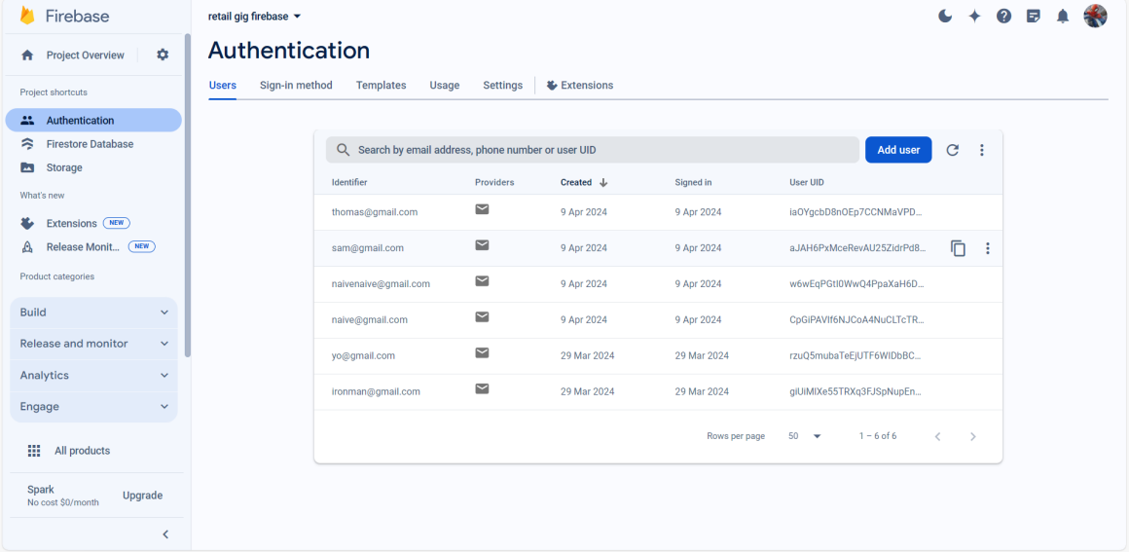

* Real-time Database**:** Firebase Realtime Database provides a NoSQL database hosted in the cloud for storing and syncing data instantly between several clients**.** Effective data management and smooth data synchronization between the frontend and backend of the application are made possible by the database's automatic data synchronization, offline support, and scalable cloud infrastructure.

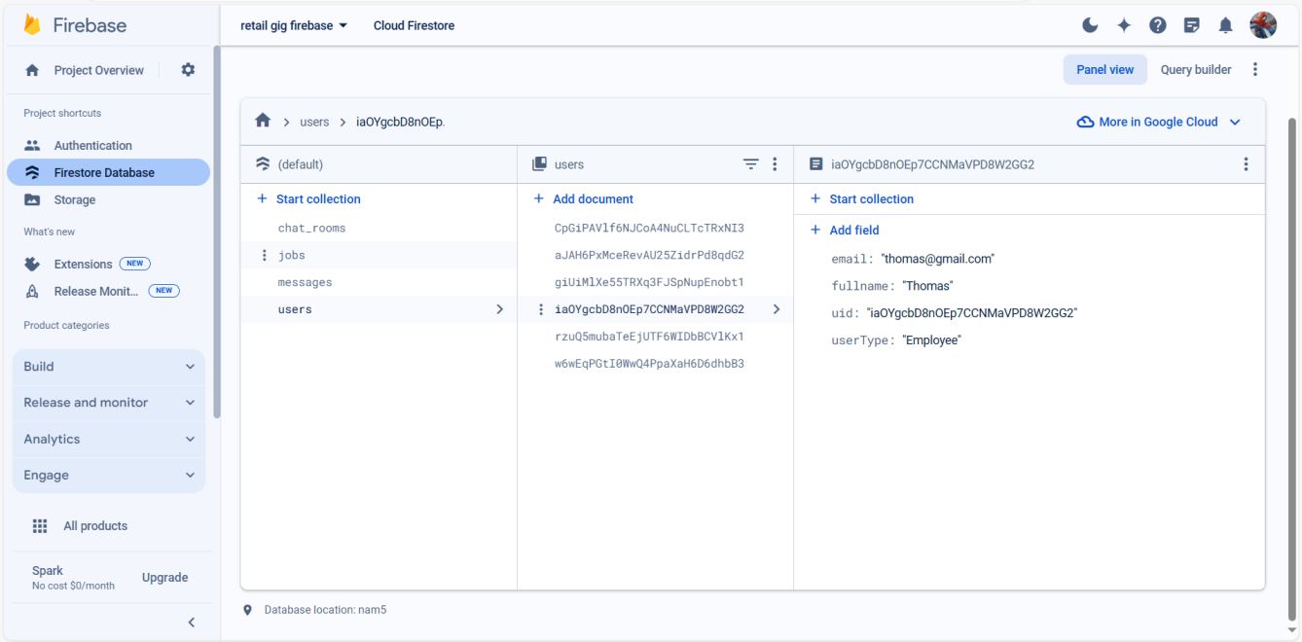

* Cloud Storage**:** Media files, application data, and user-generated material can all be safely stored in the cloud with Firebase Cloud Storage**.** In addition to enabling capabilities like file uploads, downloads, and access control policies, the scalable storage system provides high availability, durability, and low latency access to stored assets.

## 5.2 Development Process

The Retail "Gig" Mobile Application was developed using an agile development process, continuous integration/continuous deployment (CI/CD) pipelines, industry best practices, and iterative and collaborative methods to guarantee timely, high-quality, and efficient delivery of the finished product.

### Agile Methodology

Agile approaches, such Scrum or Kanban, were included into the development process to facilitate frequent feedback cycles, adaptable planning, and iterative development. Each sprint of the project was devoted to a particular set of features, user stories, or development activities. Daily stand-up meetings, sprint reviews, and regular sprint planning allowed team members to communicate, coordinate, and monitor each other's work.

### Continuous Integration/Continuous Deployment (CI/CD)

The build, test, and deployment procedures were automated with the establishment of a CI/CD pipeline, guaranteeing the timely and dependable delivery of updates and new features to the production environment. Automated testing suites, code quality checks, and deployment scripts integrated with cloud-based build/deployment platforms (like Firebase Hosting) and version control systems (like Git) were all part of the CI/CD process. Fast iteration, early bug discovery, and the smooth distribution of program updates to end users were all made possible by this optimized development methodology.

### Collaboration Tools

To support communication, collaboration, and project management activities amongst distributed teams, collaboration tools like project management platforms (Jira, Trello), version control systems (Git, GitHub), communication channels (Slack, Microsoft Teams), and virtual collaboration environments (Zoom, Google Meet) were used. Through the use of these technologies, team members were able to collaborate in real-time, track tasks, resolve problems, and share information, which promoted alignment and synergy throughout the development lifecycle.

# Market Analysis and Industry Impact

The retail industry, which is undergoing substantial transition due to a number of variables including growing workforce demographics, changing consumer behaviors, and technological improvements, is the dynamic terrain in which the Retail "Gig" Mobile Application operates. A comprehensive market study offers insightful information about current trends and potential future developments, assisting stakeholders in comprehending the competitive environment and spotting growth possibilities.

## Market Analysis

* Shift Towards Flexible Work Arrangements: The retail industry has seen a noticeable trend in favor of flexible work arrangements in recent years. Numerous causes, such as the growth of the gig economy, shifting demographics, and employees' growing need for work-life balance, are driving this trend. Because of this, retailers are using flexible employment models more and more to accommodate varying demand while giving workers more control over their schedules.
* Digital Transformation: The retail sector is undergoing a swift digital revolution, with technology significantly influencing how businesses function and interact with their clientele. Retailers now depend heavily on mobile applications to provide individualized shopping experiences, optimize operations, and collect important consumer data for analytics and insights. Taking advantage of this trend, the Retail "Gig" Mobile Application offers a digital platform for shift scheduling and staff management.
* Focus on Employee Engagement: The prioritization of employee engagement has been evident for shops seeking to improve efficiency, lower attrition, and provide outstanding customer care. Retailers are spending money on initiatives like offering flexible work schedules, acknowledging accomplishments, and providing training and development opportunities in order to improve employee morale and job satisfaction. By giving workers more control over their work schedules and enabling easy communication with management, the Retail "Gig" Mobile Application aids in these initiatives.

## Industry Impact:

* Retailers**:** The Retail "Gig" Mobile Application allows retailers to increase employee satisfaction, streamline workforce management procedures, and run their businesses more efficiently. This has a revolutionary effect on retailers. Retailers can lower labor expenses, avoid schedule conflicts, and guarantee sufficient staffing levels to satisfy client demand by utilizing the program. Additionally, the platform encourages managers and staff to collaborate and communicate better, which raises output and improves service quality.

* Employees**:** The app gives retail staff members more flexibility and convenience when it comes to scheduling their work, applying for shifts, and interacting with management. Enhancing employee autonomy and work-life balance are the benefits of having access to real-time shift postings, receiving information about opportunities, and tracking work hours. The software also makes it easier for managers and staff to communicate openly, which enables prompt assistance and feedback.

# Project Scope

The Retail "Gig" Mobile Application offers an extensive range of features that cater to the requirements of retail industry participants, including employees. The following are the main elements of the project scope:

## User Authentication System

Retail managers and staff will have secure access to the application thanks to a strong user authentication system. Email/password login and social sign-in choices are among the authentication methods that will give consumers freedom and convenience when using the platform.

## Shift Posting and Application Process

Retail managers will be able to publish work shifts with specifics like the date, time, location, and requirements for the position on a worldwide employment board. Workers can look through available shifts, apply for jobs that catch their eye, and get updates on the progress of their applications. Retailers will be able to manage their workforces more effectively thanks to the program, which will streamline the shift posting and application process.

## Calendar Integration

The shop manager's and the employee's calendars will automatically update with the shift specifics once a shift application is approved. By ensuring accountability and visibility for scheduled shifts, this integration helps both parties keep organized and aware of their impending work obligations.

## Messaging System

A messaging system included into the software will make it easier for staff and retail managers to communicate. Through the program, managers may directly answer staff questions, share shift details, and give directions. The message system fosters a healthy work atmosphere and ensures effective communication channels by improving coordination and collaboration between managers and employees.

## Technology Stack

The Retail "Gig" Mobile Application will be developed using the Flutter framework, which enables cross-platform mobile app development and offers an iOS and Android device user experience that is similar to native. Backend services, authentication, and real-time database management will be handled by Firebase, which provides scalability, dependability, and a smooth interface with the Flutter framework. The program will also give top priority to security, performance, and user experience in order to provide merchants and staff with a reliable and easy-to-use solution.

The Retail "Gig" Mobile Application seeks to transform workforce management in the retail sector by abiding by the project scope as specified and utilizing cutting-edge technology, enabling both employees and merchants to prosper in the fast-paced market of today.

# Timeline

The project team carefully planned, carried out, and iteratively improved each step of the development lifecycle during the course of the two-week development timetable for the Retail "Gig" Mobile Application. The schedule was thoughtfully designed to guarantee effective use of available resources, compliance with project deadlines, and prompt delivery of the finished product.

## Week 1: Planning and Prototyping

### Day 1-2: Project Kickoff and Requirements Gathering

* Establishing communication channels, identifying project objectives, and gathering the development team were all part of the project kickoff.
* To obtain important functional and non-functional requirements from stakeholders, such as retail managers, staff members, and end users, requirements collecting sessions were held.
* Together, the team produced wireframes, user stories, and mockups to show the functionality and design of the application.

### Day 3-4: Technical Architecture Design

* The system architecture, which includes front-end and back-end components, database schema, and integration points, was designed in conjunction with developers and technical architects.
* To guarantee a reliable and future-proof system, considerations for scalability, performance, security, and maintainability were taken.
* Frameworks, libraries, and technologies were chosen with an emphasis on Flutter for front-end development and Firebase for back-end services, taking into account how well they fit the project needs.

### Day 5-6: Development Setup and Environment Configuration

* Project management software, version control systems, and integrated development environments (IDEs) were built up.
* To enable version control and collaborative development, branching methods and Git repositories were set up.
* The Firebase project setups, which included cloud function deployment, database initialization, and authentication setup, were finished.

## Week 2: Implementation and Testing

### Day 7-9: Front-end Development

* Using the Flutter framework, front-end developers started implementing the interactive elements, navigation flows, and user interface (UI) components.
* In order to ensure compatibility with the project's visual and branding criteria, functional UI components were translated from design mockups and wireframes.
* We used iterative development cycles, doing frequent design reviews and feedback sessions to improve the UI/UX and fix any usability problems.

### Day 10-12: Back-end Development and Integration

* The implementation of server-side logic, such as authentication endpoints, API connections, and database interactions through the use of Firebase services, was the primary emphasis of back-end developers.
* To store and retrieve user and shift-related data efficiently, data models were established and data access patterns were refined.
* To verify communication between the front-end and back-end components, integration testing was carried out to guarantee smooth data flow and system compatibility.

### Day 13-14: Testing, Deployment, and Finalization

* To find and fix any flaws or inconsistencies, quality assurance (QA) engineers carried out thorough testing, which included unit testing, integration testing, and end-to-end testing.
* Upgrades and improvements could be smoothly sent out to production environments thanks to deployment pipelines that were set up to automate the deployment process.
* To verify the application's functionality, usability, and performance against predetermined acceptance criteria, user acceptance testing, or UAT, was carried out.
* Based on user input and testing findings, final tweaks and improvements were made to ensure a polished and error-free application that was prepared for release.

# Risk Analysis

Throughout the project lifecycle, a number of inherent risks and obstacles were systematically discovered, assessed, and mitigated in conjunction with the development of the Retail "Gig" Mobile Application. The project team was able to reduce probable impediments' negative effects on the project's success by anticipating them proactively and implementing effective mitigation techniques through a thorough risk analysis.

## Technical Risks

Dependency Compatibility**:** Integration problems and conflicts arising from incompatibilities between third-party libraries, frameworks, and plugins and the Flutter ecosystem were a potential concern. During the development process, extensive compatibility testing was carried out to reduce this risk, and alternate solutions were found for any incompatible requirements.

Security Vulnerabilities**:** Data breaches and unauthorized access are among the security risks associated with handling sensitive user data, such as login passwords and personal information**.** Strong security controls, such as access restriction, authentication, and encryption, were put in place at the application and backend levels in order to reduce this risk.

## Operational Risks

Deployment Failures**:** There was a chance that the deployment procedure might go wrong due to things like setup mistakes, problems with the deployment pipeline, and outages during upgrades**.** Automated deployment pipelines were set up to speed up the deployment process and reduce human error rates, and deployment methods were fully documented to reduce this risk.

Scalability Challenges: Under high load conditions, the scalability of the database and application architecture presented a danger of resource exhaustion and performance degradation**.** The architecture was made to be scalable, with features for load balancing, resource optimization, and horizontal scaling to handle increasing user demand and guarantee peak performance, in order to reduce this risk.

## Project Management Risks

Scope creep**:** This phenomenon increased the possibility of resource overuse, project delays, and project goal deviations. The project scope was meticulously established and recorded, with distinct parameters and deliverables specified in the project plan, in order to reduce this risk. All suggested additions or modifications were ranked according to their influence on the project's goals and schedules after being assessed using predetermined standards.

Resource Constraints**:** The risk of project delays and quality compromises was increased by the limited availability of resources, including time, money, and trained developers. Resource allocation was carefully designed to reduce this risk, with a focus on utilizing current knowledge, streamlining development processes, and ranking jobs according to their importance and influence on project objectives.

# Conclusion

To sum up, the process of developing the Retail "Gig" Mobile Application has been both demanding and fruitful, resulting in the development of a strong and user-focused platform that has the potential to completely transform the labor ecosystem within the retail sector. We carefully adhered to a disciplined strategy during the whole development process, utilizing state-of-the-art technologies and industry best practices to provide a feature-rich and smooth application that meets the needs of both retail managers and staff.

The project started with a thorough planning phase during which requirements were gathered, project objectives were established, and technical architecture was created. Setting the stage for later development efforts, it made sure that the project's objectives and stakeholder expectations were in line. We moved on to the implementation phase with a well-defined roadmap in place, where we used the Flutter framework and Firebase services to construct front-end and back-end components iteratively.

The application's strong functionality, which includes a variety of functions to meet the various needs of store managers and staff, is one of its main selling points. The job posting and application procedure simplifies the recruitment process by enabling managers to post job shifts and employees to apply for them with ease. The user authentication system offers a safe and smooth login experience. The incorporation of a calendar system guarantees effective scheduling and shift management, while the message system enables smooth communication between managers and staff, boosting teamwork and output.

Strict testing and quality assurance procedures were used throughout the development lifecycle to find and fix any flaws or inconsistencies, guaranteeing a well-maintained and error-free program. The application's functionality, usability, and performance were validated through continuous feedback loops and user acceptability testing, which led to an improved and user-friendly experience for all stakeholders.

In the future, the Retail "Gig" Mobile Application has the potential to revolutionize the retail sector by increasing overall productivity, streamlining operations, and optimizing personnel management. The application, with its user-friendly interface, strong features, and expandable structure, has the potential to dominate the industry and bring about a significant transformation in the sourcing, management, and deployment of retail labor.

To sum up, the Retail "Gig" Mobile Application's successful development and launch demonstrate our dedication to quality, innovation, and client pleasure. As we move on with the next stage of the journey, we are committed to providing value-driven solutions that improve user lives globally, empower businesses, and streamline processes.

# References

*Cloud firestore*. (n.d.). Flutter.dev. Retrieved March 31, 2024, from https://firebase.flutter.dev/docs/firestore/usage/

*Exploring the essentials of Flutter Calendar*. (n.d.). Dhiwise.com. Retrieved March 31, 2024, from https://www.dhiwise.com/post/get-organized-with-flutter-calendar-essentials-a-comprehensive-tutorial

*Get started with firebase authentication on flutter*. (n.d.). Firebase. Retrieved March 31, 2024, from https://firebase.google.com/docs/auth/flutter/start

SolGuruz. (2023, October 24). *Choosing the right model for Flutter app development: Freelance, in-house, or outsourcing*. Medium. https://medium.com/@solguruz/choosing-the-right-model-for-flutter-app-development-freelance-in-house-or-outsourcing-4320cc0217e4

Tashildar, A., Shah, N., Gala, R., Giri, T., & Chavhan, P. (n.d.). *Application development using flutter*. Irjmets.com. Retrieved March 31, 2024, from https://www.irjmets.com/uploadedfiles/paper/volume2/issue_8_august_2020/3180/1628083124.pdf